EXP: 12

Program-1: Write a function that uses WHILE statement to build a string repeatedly until the value of the variable becomes x greater than 5. Then, we display the final string using a SELECT statement.
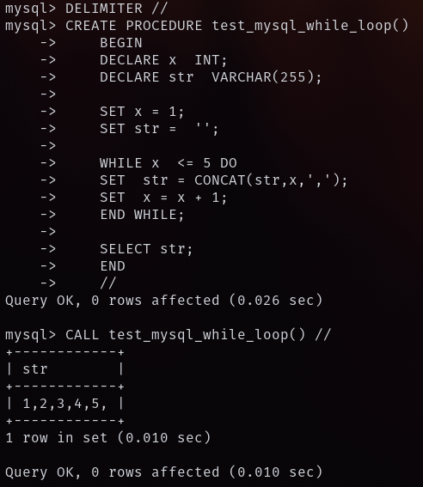

Program-2: Write a function that uses REPEAT statement which would repeat the loop until income is greater than or equal to 4000, at which point the REPEAT loop would be terminated.
